FRACTIONS

What is a fraction Facts
Fractions are something that is divided Fractions are not always
Equally. There are two parts of a fraction, numbers, they can be lines or
The numerator and denominator. The shapes. The denominator is how
Numerator goes at the top ,the many parts you split something.
Denominator goes at the bottem the Numerator is how many you take away

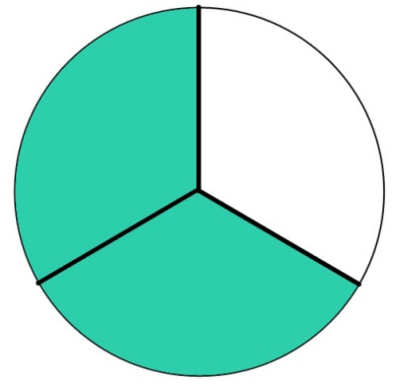
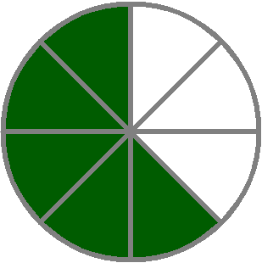
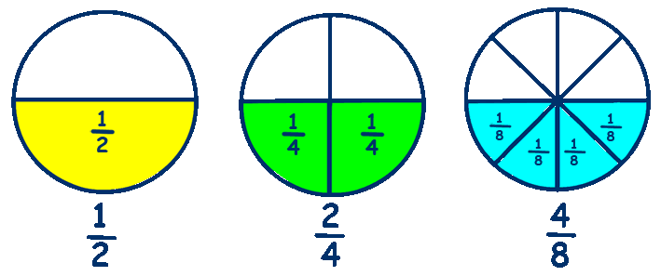
PICTURES

